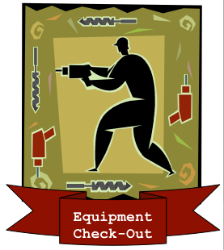 | Equipment Check-Out Services [ECS]  Phone: 555-555-5555  Fax: 555-555-5554 |  | 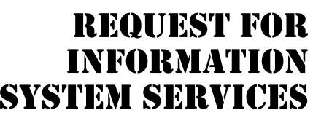
DATE OF REQUEST |  | SERVICE REQUESTED FOR DEPARTMENT(S)
05/13/2007 |  | Equipment Warehouse

SUBMITTED BY (key user contact) | EXECUTIVE SPONSOR (funding authority)
Name Steffen L. Norgren | Name Dan Stantz
Title Systems Analysts, ISS Department | Title Equipment Manager
Office 2B | Office 02B
Phone 555-555-4555 | Phone 555-555-5345

TYPE OF SERVICE REQUESTED:
Information Strategy Planning Existing Application Enhancement
Business Process Analysis and Redesign Existing Application Maintenance (problem fix)
New Application Development Not Sure
Other (please specify _______________________________________________________________________

BRIEF STATEMENT OF PROBLEM, OPPORTUNITY, OR DIRECTIVE (attach additional documentation as necessary)
Equipment Check-Out Services [ECS] is using a 20-year old manual input system for managing the checking in/out of equipment to their maintenance employees. The current system has not scaled well with ECS’ growth over that time and has grown inefficient, leading to long waits to check equipment in and out during peak hours. Their current system is also unable to track individual items of equipment to specific employees and this had lead to equipment being lost, damaged and stolen. It is estimated that this costs the company $50,000 a year in lost and stolen equipment. Safety is another concern for ECS as there is currently no method in place to ensure that only qualified employees can check-out certain pieces of equipment.

BRIEF STATEMENT OF EXPECTED SOLUTION
We envision the creation of automated equipment management system, which utilizes bar-codes and RFID tags to identify every piece of equipment in their inventory. When an employee checks out any piece of equipment, the system will automatically check whether they are qualified to use the equipment in question (via a link to the HR database) and automatically check-out the equipment under that specific employee’s ID. As such, any equipment that is checked-out will be linked to a specific employee and job site, so that in the event of equipment loss or damage it can be linked to a specific employee. This system will also facilitate the streamlining of check-in procedures and the employee will no longer have to wait in line during peak periods as they can simply drop the equipment off at the depot to be checked in by the staff when time permits.

ACTION (ISS Office Use Only)
Feasibility assessment approved Assigned to Steffen L. Norgren

Feasibility assessment waived Approved Budget $ ___350,000__________
Start Date ASAP Deadline _ASAP___
Request delayed Backlogged until date: ______________
Request rejected Reason: ________________________________________________
Authorized Signatures:
_____________________________________ _________________________________________________
Project Executive Sponsor

